Primeiro Desafio

Felipe Israel Corrêa

**VHDL**

library IEEE;

use IEEE.std_logic_1164.all;

entity latch_d is

port (

D1, D2 : in bit;

ENB : in bit;

Q1, Q2 : out bit

);

end latch_d;

architecture nv_logic of latch_d is

begin

Q1 <= D1 when ENB='1';

Q2 <= D2 when ENB='1';

end nv_logic;

**RPL**

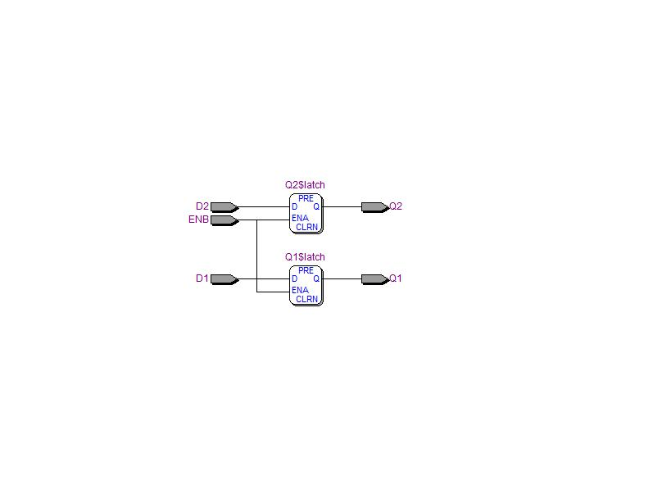

**Sim waveform**

